Announcements Archive: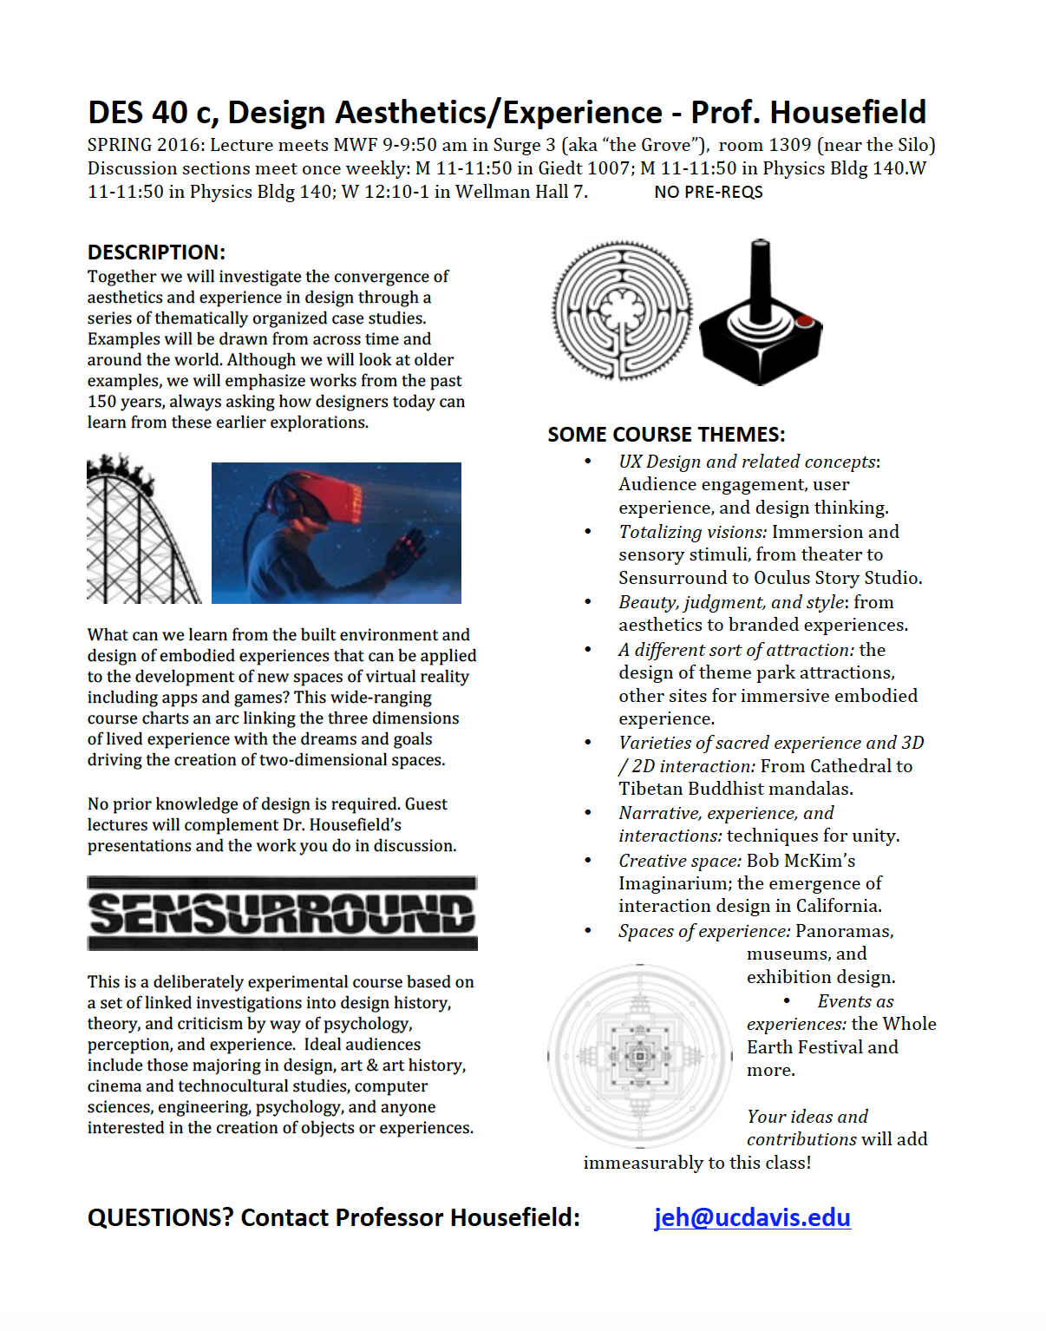

Pence Showing // The Consilence of Art & Science 2016

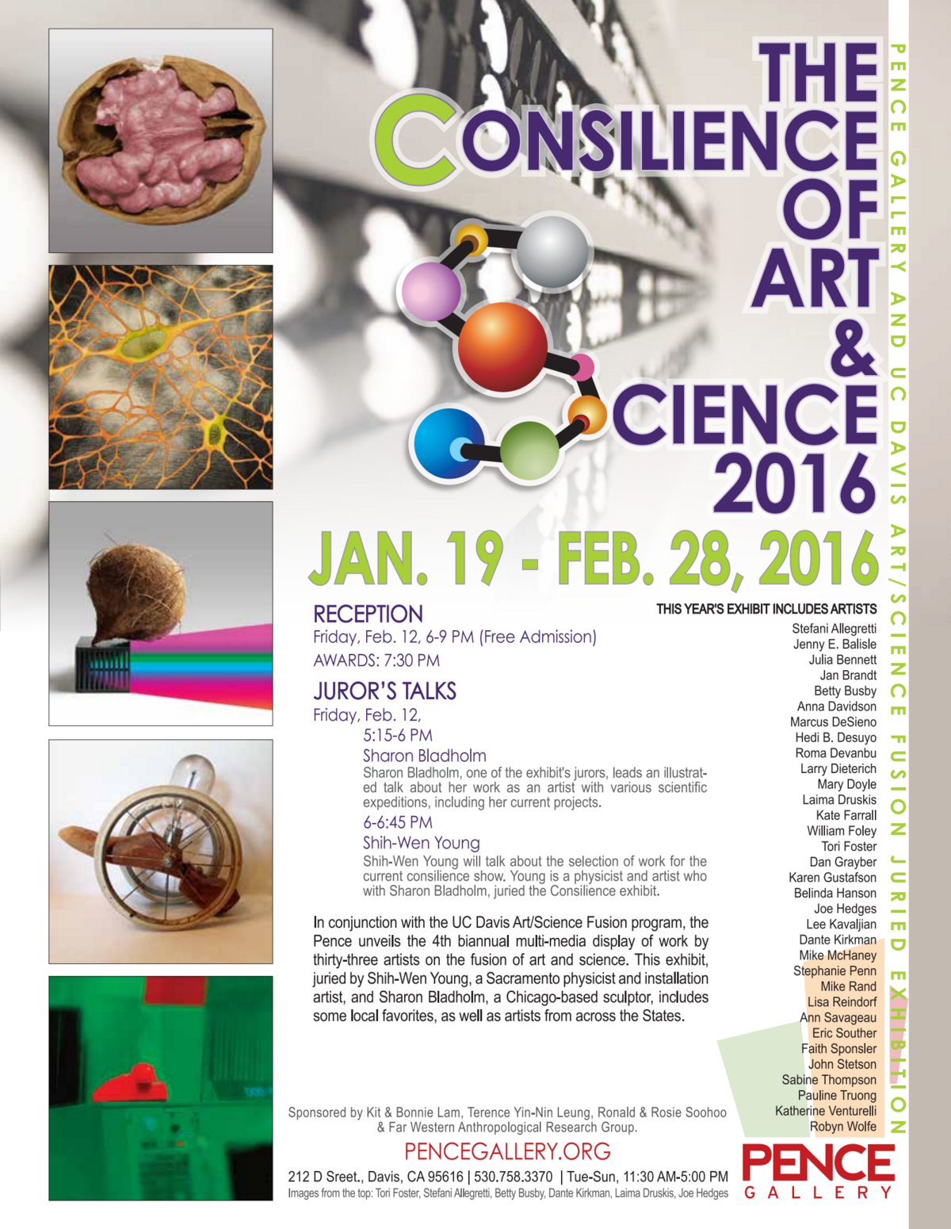

//Design by Design

If you are interested in submitting your work, please email Michelle for the submittal paperwork.

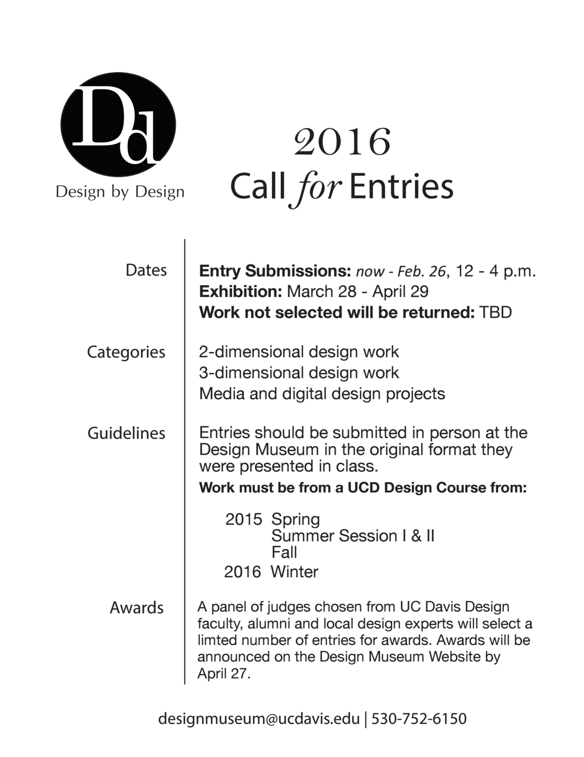

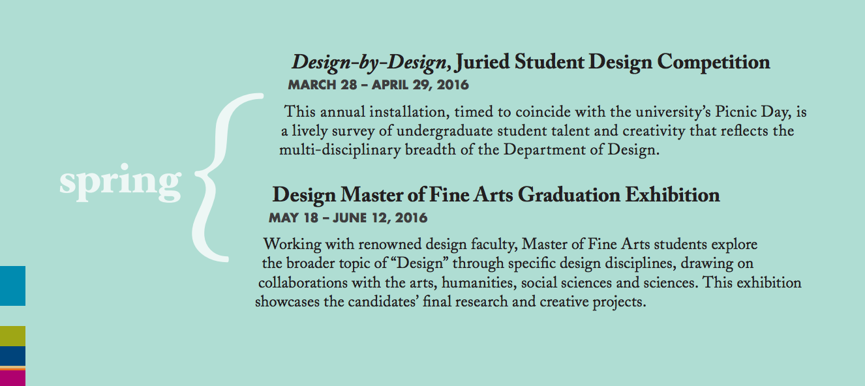

//February 3rd

DeYoung

Deadline to Submit: **March 6th, 2016.**

Michelle will email out submission form. Please ask her if you did not receive it.

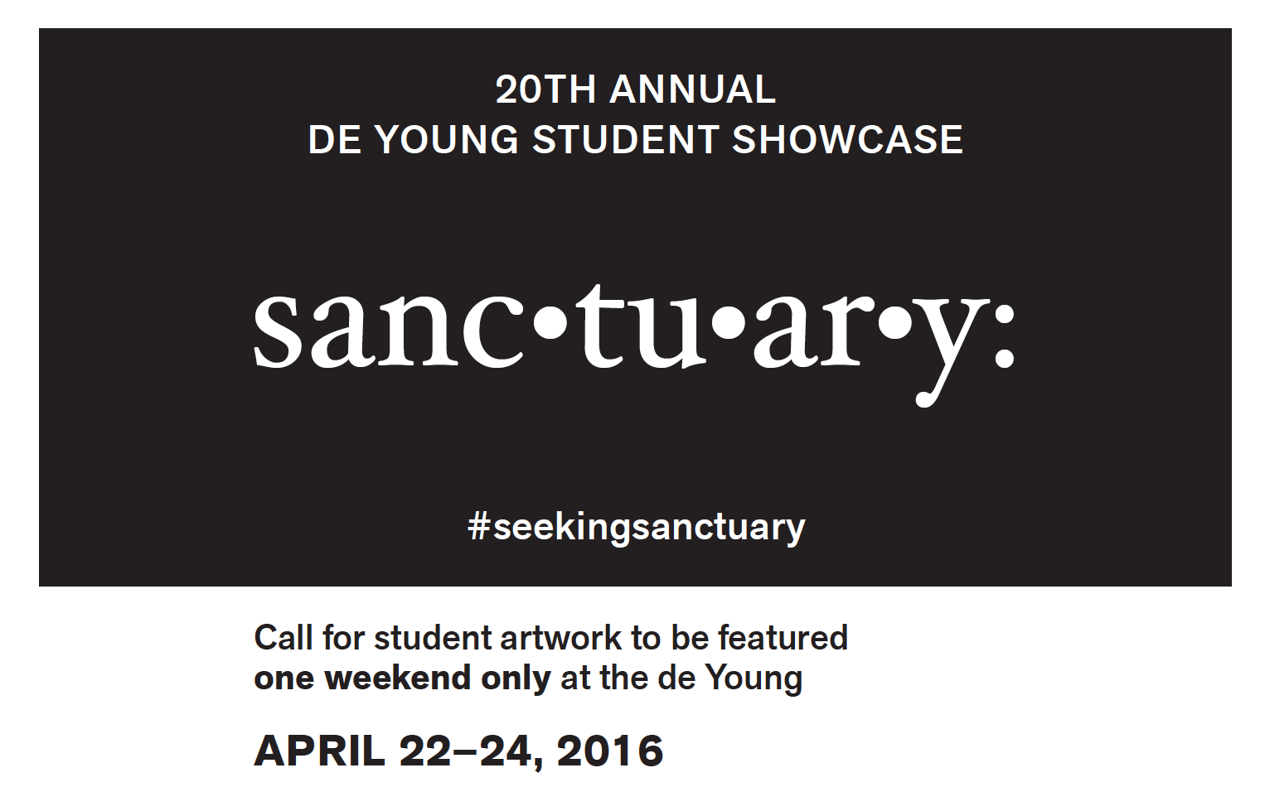

//BioDesign (DES198) taught by Christina Cogdell

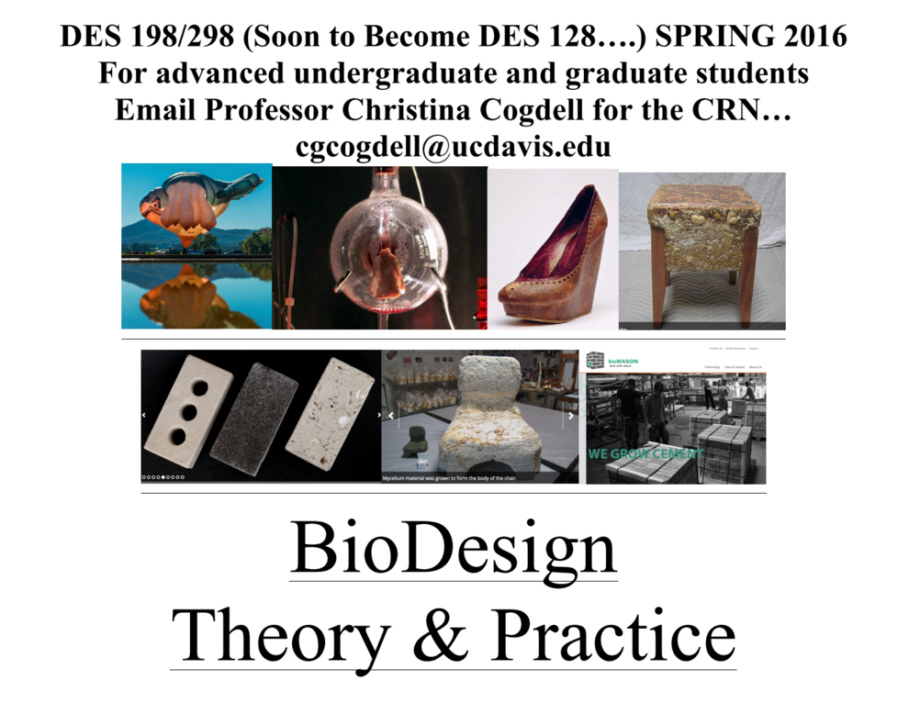

//Jan 25:

[**Platforms**](https://www.cca.edu/news/2016/01/06/ccas-architecture-division-presents-platforms-augmented-histories-space-january-28) is sponsored by the CCA Architecture / Experimental History Project and explores an array of new digital tools for uncovering the history of buildings and cities.

The event convenes experts from the worlds of academia, technology, art, and historic preservation.

Platforms has three parts:

* a week-long exhibition (January 25-29)
* a Friday symposium (January 29, 4-7:30 p.m.)
* a Saturday event, Explore the Augmented City, that invites participants to explore San Francisco through the tools of augmented history (January 30)

<https://www.cca.edu/calendar/2015/platforms-augmented-histories-space>

[Audio recording of keynote speaker: Jeffrey Schnapp _ Harvard metaLAB (mpeg_4)](https://drive.google.com/a/ucdavis.edu/file/d/0B-aOH50QCgmibkw5YWVHN0JGU1k/view?usp=sharing)